Java installation:

Note:
Your IDE may already include a JDK, in which case some of the following steps will not be necessary. However, it may be possible that your IDE includes an older Java version, in which case it may still be advisable to download the newest version & configure the IDE to use it.

1. Download the java SDK from http://java.sun.com/j2se/1.4.2/download.html

Notes:
- At the time this document was written, 1.4.2 was the latest release
Version (while version 1.5 beta is also available for download)
- We require j2SE , which is the standard edition.

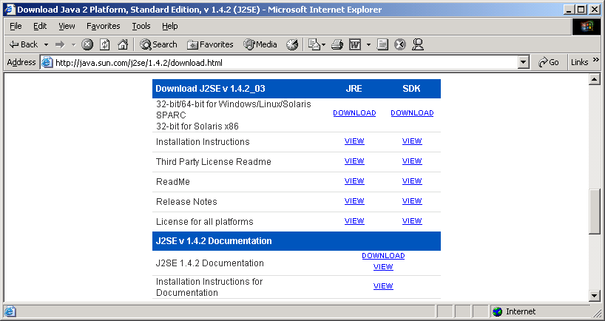

2. Install .
Let us assume you have chose to install into c:/j2sdk1.4
This directory is commonly referred to as JAVA_HOME

3. Optionally:
Define environment variables as follows:

JAVA_HOME=c:/j2sdk1.4

PATH=%JAVA_HOME%/bin;………….
Your existing PATH
(note java comes first )

Note:
JAVA_HOME is sometimes required by some java-based tools.
The addition to PATH is meant to allow easy access to the SDK command-line tools such as java.exe, javac.exe

- To set up environment variables in windows NT, 2000 or XP

- right-click on “My Computer” -> properties
- Open the “advanced” tab and press “environment variables (for windows NT, open the “environment” tab)
- Make sure your variables are “System Variables” (rather than “User Variables”)

4. Download the documentation from the same Sun page mentioned in previous section.
Documentation arrives at the form of a zip file, which may be extracted – preferable into c:/j2sdk1.4/docs

5. Install your IDE.
Some freely available IDEs:

- Eclipse:
Available at: http://www.eclipse.org.
Installation: download zip file, and uncompress it anywhere.
Run the eclipse.exe executable.

- Netbeans:
Available at http://www.netbeans.org

